Feedback Logger Service
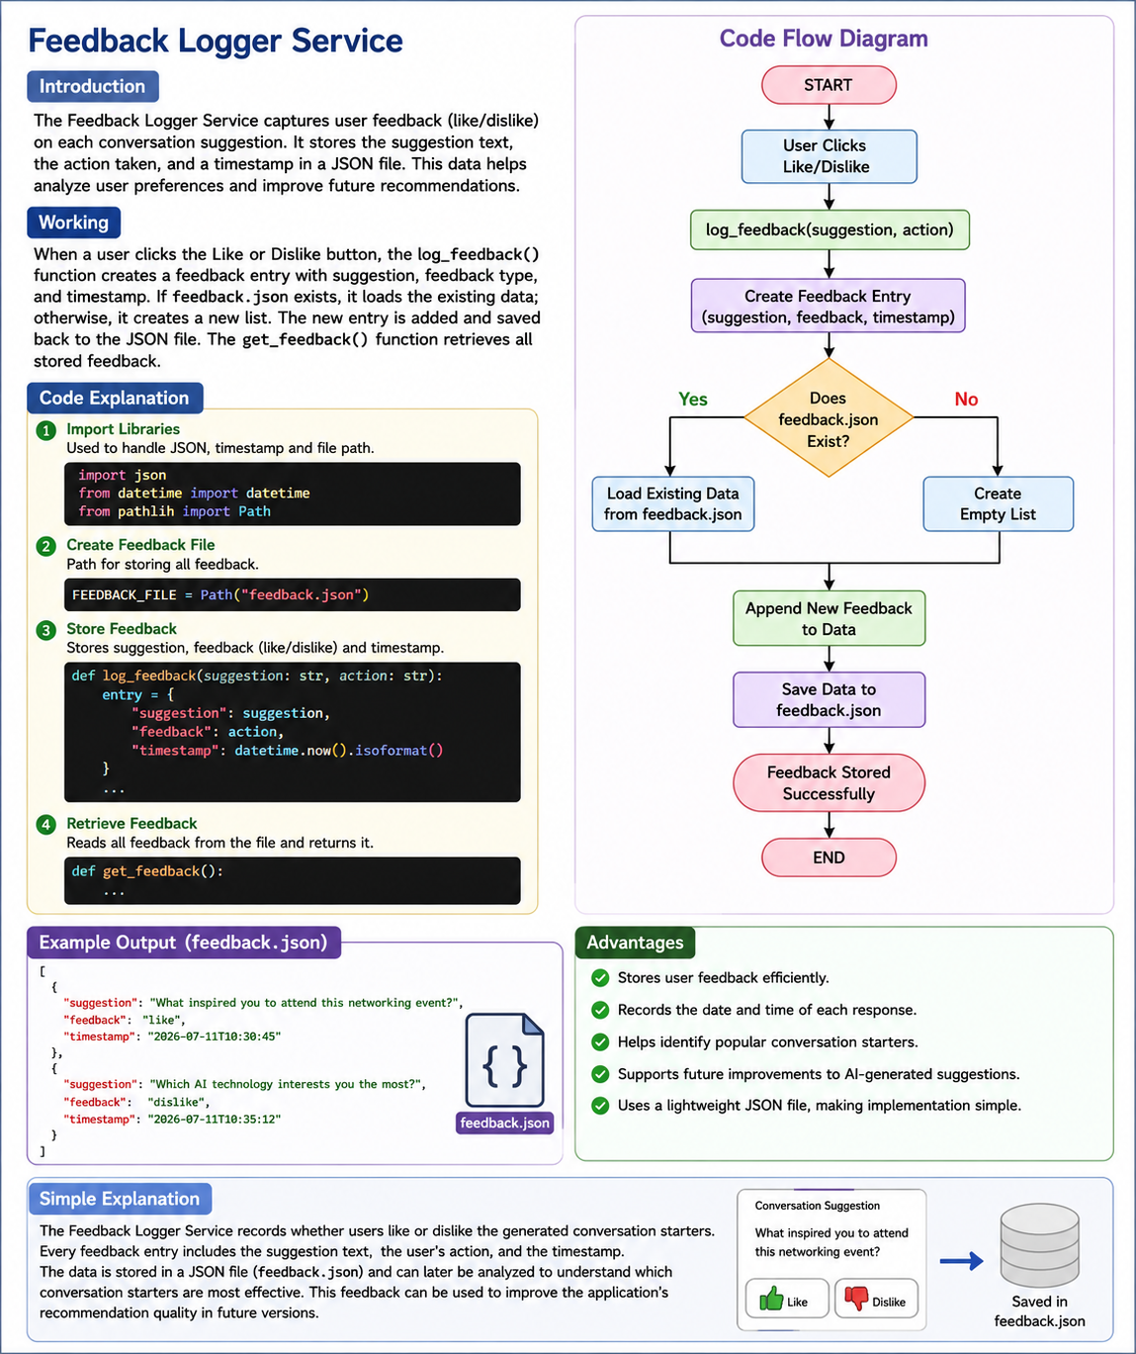

Introduction:
The Feedback Logger Service is responsible for collecting and storing user feedback on the conversation suggestions generated by the Personalized Networking Assistant. Users can express their opinion by clicking the Like or Dislike button. The feedback is stored in a JSON file along with the suggestion text and timestamp, allowing the system to analyze user preferences and improve future recommendations.

Working:
The Feedback Logger Service records every feedback submitted by the user. When a user selects Like or Dislike, the log_feedback() function creates a feedback entry containing the suggestion, the feedback type, and the current timestamp. If the feedback.json file already exists, the existing data is loaded; otherwise, a new file is created. The new feedback is then added and saved to the JSON file. The get_feedback() function is used to retrieve all stored feedback whenever required.

Code Flow Description:
The execution begins by importing the required libraries: json, datetime, and Path. A file named feedback.json is created to store feedback records. When the log_feedback() function is called, it receives the suggestion text and the user's action (Like or Dislike). A feedback entry is created with the suggestion, feedback type, and timestamp. The program checks whether feedback.json already exists. If it exists, the previous data is loaded; otherwise, an empty list is created. The new feedback is appended to the list and saved back to the JSON file. The get_feedback() function reads the stored feedback and returns it whenever needed.

Advantages:
1.Stores user feedback in a structured format.
2.Records the time of each feedback submission.
3.Helps identify popular conversation suggestions.
4.Supports future improvements to AI-generated recommendations.
5.Uses a lightweight JSON file for easy storage and retrieval.

Conclusion:
The Feedback Logger Service is an important component of the Personalized Networking Assistant. It collects user feedback efficiently and stores it for future analysis. By analyzing users' likes and dislikes, the system can continuously improve the quality and relevance of the conversation starters, making the application more personalized and effective over time.

